​CBSE Class 10: Our Environment (Short Answer Questions)
​Q1. What is an ecosystem? Name its two main components.
​Answer: An ecosystem is a self-sustaining structural and functional unit of the biosphere where living organisms interact among themselves and with their surrounding physical environment.
Its two main components are:
- ​Biotic components: Living factors like plants, animals, and decomposers.
- ​Abiotic components: Non-living factors like air, water, soil, temperature, and sunlight.
​Q2. Why are green plants called producers?
​Answer: Green plants are called producers because they synthesize their own organic food (glucose) from simple inorganic raw materials (carbon dioxide and water) using sunlight and chlorophyll through the process of photosynthesis. They trap solar energy and make it available for the rest of the ecosystem.
​Q3. Decomposers play a critical role in the environment. Justify this statement with two reasons.
​Answer: Decomposers (like bacteria and fungi) are essential because:
- ​They break down complex organic matter from dead plants and animals into simple inorganic substances, recycling nutrients back into the soil.
- ​They act as environmental cleansers by disposing of organic waste, preventing the accumulation of dead remains and foul odors.
​Q4. State the 10% Law of energy transfer. Who proposed it?
​Answer: The 10% Law (proposed by Raymond Lindeman) states that during the transfer of energy from one trophic level to the next in a food chain, only about 10% of the available energy is utilized and stored at the higher trophic level. The remaining 90% is lost as heat to the environment or used in life processes like respiration and digestion.
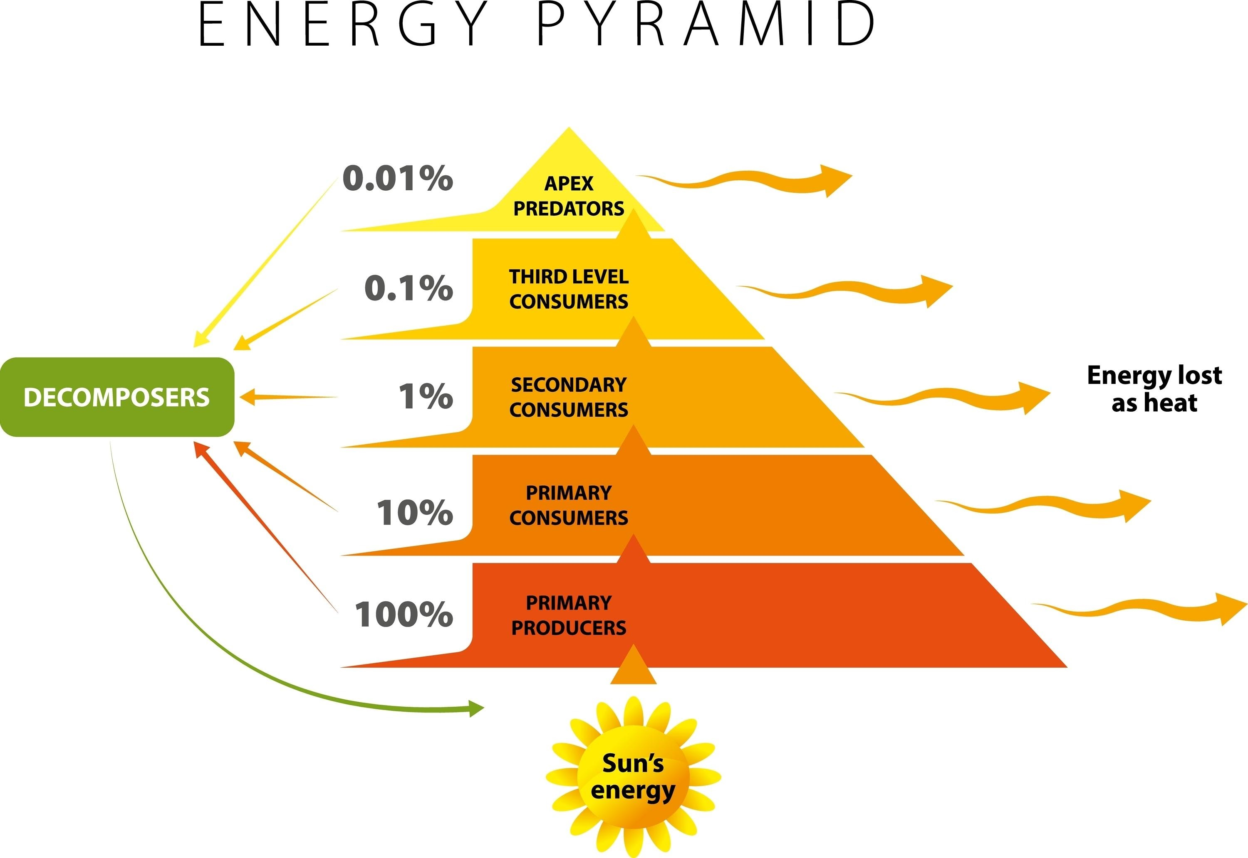
Q5. Why is a food chain generally limited to only 3 to 4 trophic levels?
​Answer: According to the 10% law, energy decreases drastically at each successive trophic level. By the time energy reaches the fourth or fifth trophic level, the amount of available energy becomes so small and insufficient that it can no longer support another viable trophic level.
​Q6. What is biological magnification? Give an example.
​Answer: Biological magnification (or biomagnification) is the phenomenon of progressive accumulation of non-biodegradable chemicals (like pesticides or heavy metals) at higher concentrations at each successive trophic level of a food chain.
- ​Example: When DDT is sprayed on crops, it enters the water bodies, gets absorbed by planktons, moves up to fish, and reaches the highest concentration in fish-eating birds or humans.
​Q7. Differentiate between biodegradable and non-biodegradable wastes.
​Answer: | Feature | Biodegradable Wastes | Non-Biodegradable Wastes |
| :--- | :--- | :--- |
| Definition | Substances broken down into harmless forms by microorganisms. | Substances that cannot be broken down by biological processes. |
| Examples | Fruit peels, paper, cotton, animal dung. | Plastics, glass, DDT, nylon, synthetic chemicals. |
| Impact | Harmful only if accumulated in massive quantities. | Persist in the environment and cause severe pollution/biomagnification. |
​Q8. What is the ozone layer and where is it located? State its function.
​Answer: The ozone layer is a belt of ozone (O_3) gas molecules located in the stratosphere (a region of Earth's atmosphere about 15–30 km above Earth). Its primary function is to shield the Earth by absorbing harmful ultraviolet (UV-B) radiation emitted by the sun, protecting living organisms from skin cancer, cataracts, and immune system damage.
​Q9. Write the chemical equations showing the formation of ozone in the atmosphere.
​Answer: Ozone is formed at higher levels of the atmosphere when high-energy UV radiation splits molecular oxygen (O_2) into free oxygen atoms. These reactive atoms then combine with molecular oxygen to form ozone:
Q10. What are CFCs? What harm do they cause to the environment?
​Answer: CFCs stand for Chlorofluorocarbons. They are synthetic chemicals widely used in refrigeration, air conditioning, and fire extinguishers. When released into the atmosphere, they drift up to the stratosphere and react with ozone molecules, breaking them down and causing the depletion of the ozone layer (commonly called the “ozone hole”).
​Q11. What was the UNEP accord of 1987 regarding CFC production?
​Answer: In 1987, the United Nations Environment Programme (UNEP) successfully forged an international agreement (the Montreal Protocol) to freeze Chlorofluorocarbon (CFC) production at 1986 levels. This collaborative effort aimed to stop further ozone depletion and allow the layer to recover.
​Q12. What will happen if we kill all the organisms in one trophic level?
​Answer: If all organisms at one trophic level are killed:
​The population of organisms in the lower trophic level will increase exponentially due to the absence of predators, leading to overpopulation and resource exhaustion.
​The organisms in the higher trophic level will starve and die due to the sudden elimination of their food source, disrupting the entire ecosystem’s balance.
​Q13. Why is damage to the ozone layer a cause for concern?
​Answer: Damage to the ozone layer allows harmful ultraviolet (UV) radiation to reach the Earth’s surface. Increased UV exposure causes severe health hazards, including:
​Skin cancer and severe sunburns in humans.
​Cataracts and damage to human eyes.
​Suppression of the immune system.
​Disruption of photosynthesis in phytoplankton and crop plants, damaging marine and terrestrial food webs.
​Q14. What is a food web? Why is it more stable than a food chain?
​Answer: A food web is a network of interconnected food chains operating within an ecosystem, showing the multiple feeding relationships among different organisms.
It is more stable than a linear food chain because it offers alternative pathways for energy flow. If one species of prey decreases, a predator can rely on an alternative prey, preventing the collapse of the ecosystem.
​Q15. Suggest two eco-friendly methods for garbage disposal in urban areas.
​Answer: 1. Composting: Converting organic biodegradable wastes (like kitchen waste, leaves, and food scraps) into nutrient-rich manure by burying them in a compost pit.
2. Recycling: Segregating non-biodegradable wastes like plastics, metals, and glass so they can be processed and remanufactured into new products instead of overloading landfills.

